2023 Knowlesville Art & Nature Centre:
Parent & Child Registration Form

STUDENT INFORMATION

First Name: ______________________ Last Name:__________________________
Age: ______ Birth date (yy/mm/dd): ___/____/_____ Preferred Pronoun (she/he/they): ______
Allergies/Dietary Restrictions or Preferences: __________________________________________________________________________________________________________________________________
Healthcare Number: __________________________
Family Doctor: __________________ Doctor phone number: ___________________

CONTACT INFORMATION
Parent/ Guardian

First Name: _________________________ Last Name: ______________________
Address: _________________________________________________________
Postal Code: ___________ E-mail: _________________________________
Phone #: _______________ Work #: _________________ Cell #: ______________
Relationship to participant ۝ parent ۝ guardian ۝ other__________________
Authorized to pick up participant (must be given in writing or in person by the legal guardian)
1) _____________________________ 2)________________________________

Secondary Contact

First Name: ________________________ Last Name: ______________________
E-mail: __________________________________________________________
Phone #: __________________ Work #: _______________ Cell #: _____________
Relationship to participant ۝ parent ۝ guardian ۝ other _________________
Emergency Contact (used in an emergency when the two primary contacts can’t be reached)

First Name: ______________________ Last Name: _________________________
Phone #: ______________ Work #: ________________ Cell #: ________________
Relationship to participant ۝ parent ۝ guardian ۝ other _________________

Release of Liability:
As a condition of my child’s participation in the Art & Nature School, I agree to release the Knowlesville Art & Nature Centre, any establishment where the program is held, its employees and agents from any and all liability for any bodily injury, property damage, death or loss of any nature and kind that may occur from participation in any activities of the Art & Nature School.

Signature of Parent/Guardian ______________________________ Date: ____/____/____

Photo Consent:
During our activities and events staff and parents like to take photos, which we use to promote and showcase our school through social media, our website, and occasionally newsletters or blogs. By signing our photo consent you are agreeing that we may use pictures of your child for these purposes. For those preferring not to sign we are happy to accommodate. Please communicate your wishes with staff on the form provided (i.e. taking photos is ok, but you don’t want them on facebook, or if you’d rather no photos be taken at all).

I hereby give permission for images of my child, captured during regular and special Knowlesville Art & Nature Centre activities through video, photo and digital camera, to be used solely for the purposes of Knowlesville Art & Nature Centre promotional material publications, and waive any rights of compensation or ownership thereto.

Signature of Parent/Guardian ______________________________ Date: ____/____/____

Please include any additional notes/information on your child that you feel would be helpful:

Knowlesville Art & Nature Forest School Program

Parent & Child Program Details (For ages 5 and under)

At the Parent and Child program, parents accompany their young children to a morning session at our nature school. While the children play, their parents/guardians can share their caregiving experiences and ask questions. It is a wonderful opportunity to learn a bit more about our Art & Nature School, and meet new people. We will enjoy circle-time, a forest walk, songs, stories, snack and free play along side our small but bustling Forest Kindergarten class.

Starting October 26th, 2022 - the program runs from 9:00-11:30, every other Wednesday

- What to Bring: Dress for the weather, pack a small backpack that your child can carry, water bottle and a small healthy snack for you and your child. We will be in the great outdoors rain / snow or shine!

Parent & Child Session Dates:

4 Winter Parent & Child Sessions -
Wednesdays 9:00-11:30am:
Feb 1, Feb 15, Mar 1 & Mar 22, 2023

&
5 Spring Parent & Child Sessions -
Wednesdays 9:00-11:30am:
Apr 5, Apr 19, May 3, May 17 & May 31, 2023

Parent & Child Fees:
- Winter 2023 Parent & Child : $100/full session/family (4 in total) or $30/session/family
- Spring 2023 Parent & Child: $125/full session/family (5 in total) or $30/session/family

Payment Options
Pre-Payment is required to reserve your spot for the term.
Pay-as-you-go will be charged at the per session rate of $30/family

Payment can be made by cash, cheque or e-transfer.
Please make cheques payable to: Knowlesville Art& Nature Centre.
E-transfers can be sent to admin@knowlesvillenature.ca

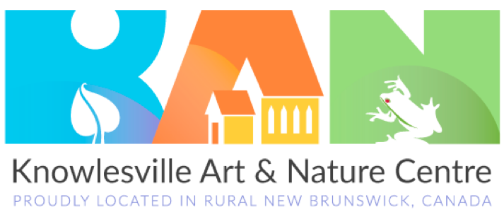

111 Simms Road, Knowlesville, NB, E7L4P7
Phone:506.375.6400 Email: info@knowlesvillenature.ca

