2022-2023 Knowlesville Art & Nature Centre:
Forest Kindergarden Registration Form

STUDENT INFORMATION

First Name: ______________________ Last Name:__________________________
Age: ______ Birth date (yy/mm/dd): ___/____/_____ Male ۝ Female ۝
Allergies/Dietary Restrictions or Preferences: __________________________________________________________________________________________________________________________________
Healthcare Number: __________________________
Family Doctor: __________________ Doctor phone number: ___________________

CONTACT INFORMATION
Parent/ Guardian

First Name: _________________________ Last Name: ______________________
Address: _________________________________________________________
Postal Code: ___________ E-mail: _________________________________
Phone #: _______________ Work #: _________________ Cell #: ______________
Relationship to participant ۝ parent ۝ guardian ۝ other__________________
Authorized to pick up participant (must be given in writing or in person by the legal guardian)
1) _____________________________ 2)________________________________

Secondary Contact

First Name: ________________________ Last Name: ______________________
E-mail: __________________________________________________________
Phone #: __________________ Work #: _______________ Cell #: _____________
Relationship to participant ۝ parent ۝ guardian ۝ other _________________

Emergency Contact (used in an emergency when the two primary contacts can’t be reached)

First Name: ______________________ Last Name: _________________________
Phone #: ______________ Work #: ________________ Cell #: ________________
Relationship to participant ۝ parent ۝ guardian ۝ other _________________

Medical Information & Consent:
It is the policy of the Knowlesville Art & Nature Centre to notify a parent/guardian when a child is ill or needs medical attention. If we cannot contact parents/guardians and need to get immediate medical assistance for the child, our procedure is to take the child to the nearest emergency service. Please sign the consent below so that we can take appropriate action on behalf of your child.

In the event that I cannot be contacted, I hereby give consent for my child __________________ to be taken to the nearest emergency centre by the staff at the Knowlesville Art & Nature Centre to receive medical treatment.
Signature of Parent/Guardian ______________________________ Date: ____/____/____

Parental Confirmation and Acknowledgment of Covid-19 Screening Responsibility:

I _______________________ (parent/guardian), hereby acknowledge that I understand my responsibilities for the screening of my child/children for COVID-19 symptoms prior to bringing my child/children to the Knowlesville Art & Nature Centre as required during times of NB public health directives.

Signature of Parent/Guardian ______________________________ Date: ____/____/____

Release of Liability:
As a condition of my child’s participation in the Art & Nature School, I agree to release the Knowlesville Art & Nature Centre, any establishment where the program is held, its employees and agents from any and all liability for any bodily injury, property damage, death or loss of any nature and kind that may occur from participation in any activities of the Art & Nature School.

Signature of Parent/Guardian ______________________________ Date: ____/____/____

Photo Consent:
During our activities and events staff and parents like to take photos, which we use to promote and showcase our school through social media, our website, and occasionally newsletters or blogs. By signing our photo consent you are agreeing that we may use pictures of your child for these purposes. For those preferring not to sign we are happy to accommodate. Please communicate your wishes with staff on the form provided (i.e. taking photos is ok, but you don’t want them on facebook, or if you’d rather no photos be taken at all).

I hereby give permission for images of my child, captured during regular and special Knowlesville Art & Nature Centre activities through video, photo and digital camera, to be used solely for the purposes of Knowlesville Art & Nature Centre promotional material publications, and waive any rights of compensation or ownership thereto.

Signature of Parent/Guardian ______________________________ Date: ____/____/____

Child Immunization Declaration:

Immunizations are not given at the school and are the responsibility and ultimate choice of the parents. However, for the safety of all, the school needs immunization records for all children that have been vaccinated. These will be held in confidence. Please note that parents should be aware that there may be non-immunized students attending the school.

Please provide written notice to your child’s teacher of new immunizations to be added to health
information records. Thanks for your cooperation.

Child’s Name: ____________________________________________________________________

My child has received a tetanus shot: Yes No If yes, please include date: ___/ ___ / ___

My child has received other immunization(s): Yes No
If yes, please list below:

Immunization | Date Received:

Parent/Guardian Signature: ______________________________________ Date:

Please include any additional notes/information on your child that you feel would assist in a successful year at school:

Knowlesville Art & Nature Forest School Program
2022-2023 Tuition Payment Schedule

Tuition for Forest School

$2880 for the year + $100 one-time material fee due at registration

Fall Term runs from September 12th 2022 to Dec 15th 2022
Winter / Spring Term runs from January10th 2023 to June 8th 2023
Note: Spring Break runs March 6-16th, 2023 - see full calendar attached

Payment Plan Options

Monthly Payment Schedule:

$390 due upon registration (non-refundable pre-payment of $290 + $100 material fee)
۝ $290 Payment due September 15th, 2022
۝ $290 Payment due October 15th, 2022
۝ $290 Payment due November 15th, 2022
۝ $290 Payment due December 15th, 2022
۝ $290 Payment due January 15th, 2023
۝ $290 Payment due February 15th, 2023
۝ $290 Payment due March 15th, 2023
۝ $290 Payment due April 15th, 2023
۝ $270 Payment due May 15th, 2023

Term Payment Schedule:

$390 due upon registration (non-refundable pre-payment of $290 + $100 material fee)
$1295 ۝ Fall Term– Payment due October 15th, 2022
$1295 ۝ Winter / Spring Term Payment due February 15th, 2023

* A Sibling discount of 20% off will be applied automatically to multiple children in the same family

Payment can be made by cash, cheque or e-transfer according to the schedule above.
Please make cheques payable to: Knowlesville Art & Nature Centre.
E-transfers should be sent to admin@knowlesvillenature.ca
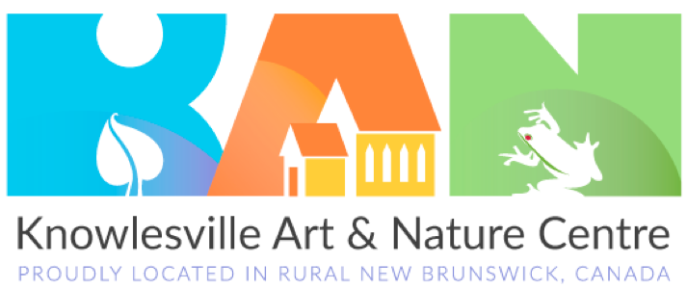
111 Simms Road, Knowlesville, NB, E7L4P7
Phone:506.375.6400 Email: info@knowlesvillenature.ca
